Brass & Iron Buckles and
Misc Brass Order Form

Enter the quantity desired in the block, and return this form with your payment.

Prices do not include shipping.

Name: _________________________________

Address:________________________________

_______________________________________

Phone: _________________________________

Email: _________________________________

Qty |  | Qty |  | Qty
CD $13 without tongue  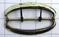  $16 with two tongues  CD-A $22 |  | 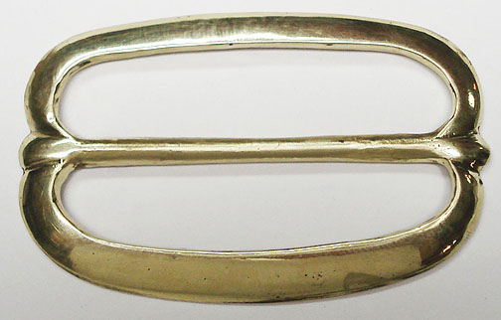  CE  $12 without tongue  $14 with tongue |  | 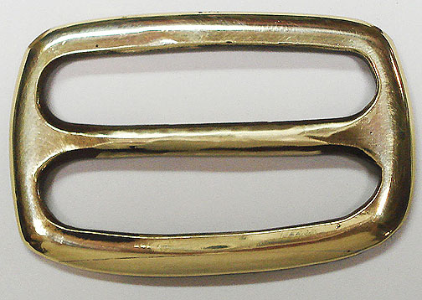  CF  $12 without tongue  $14 with tongue
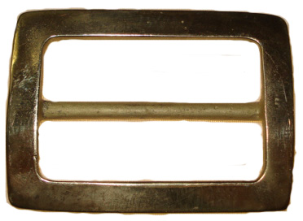  CH  $13 without tongue  $15 with tongue |  | CW  $13 without tongues  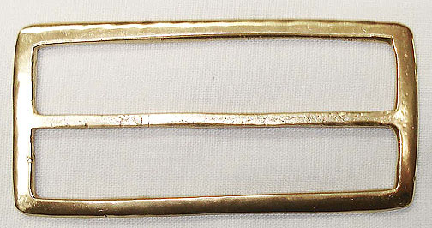  $15 with tongues |  | 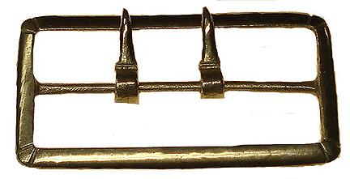  CX  $12 without tongues  $22 with tongues
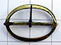  CY  $12 without tongue  $14 with tongue |  | 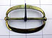  CZ  $12 without tongue  $14 with tongue |  | 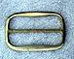  DB  $10 without tongue  $12 with tongue
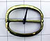  DD  $12 without tongue  $14 with tongue |  | 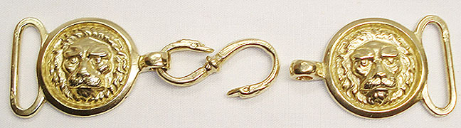  DZ $35 |  | 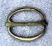  EA  $8 without tongue  $10 with tongue
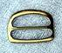  EB  $8 without tongue:  $10 with tongue: |  | EF  $10 without tongue:  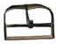  $12 with tongue: |  | 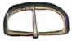  EX  $8 without tongue:  $10 with tongue:
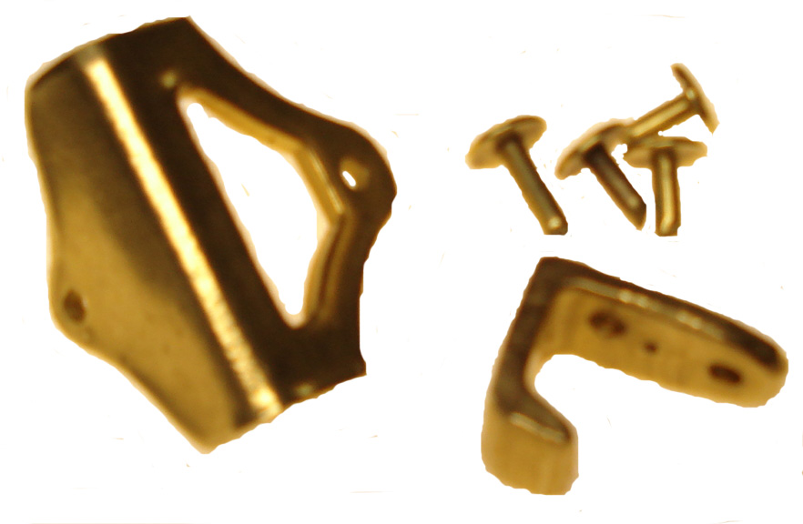  CP $35 |  | 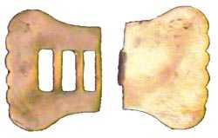  Neck Stock  Clasp set $16 |  | 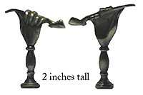  Pipe Tamper $15
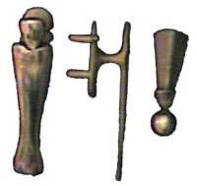  HA – sword $11 |  | HB – bayonet $8 |  | HC – chape/tip $5
Small Iron $4  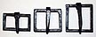  Bag of 25 buckles $75 | Medium Iron $4  Bag of 25 buckles $75 |  | Large Iron $4  Bag of 25 buckles $75 |  | Extra Large Iron $4  Bag of 25 buckles $75
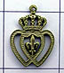  Watch Fob $6  Gold $7  Silver $7 |  | 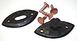  Turnable Stud  & Catch $10 |  | 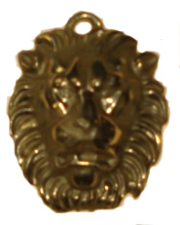  Lion $15

