Cuff Link Sets

Enter the quantity of sets desired in the block, and return this form with your payment. Prices do not include shipping.

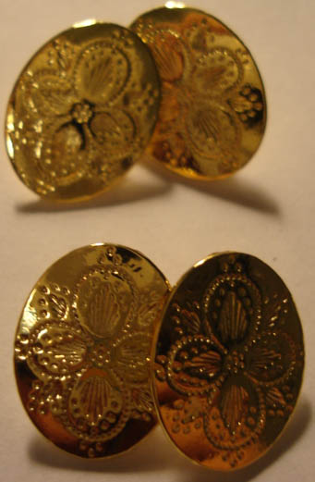
Name: _________________________________
Address:________________________________
_______________________________________
_______________________________________
Phone: _________________________________
Email: _________________________________

Each ‘set’ consists of cuff
links for two shirt sleeves.
Prices are for one ‘set’ as
pictured here.

 | Pewter  $7 | Sterling Silver Plated $10 | 24kt Gold Plated  $10
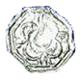
Octogon
.45” dia
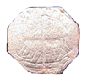
Victory Ship
.61” dia
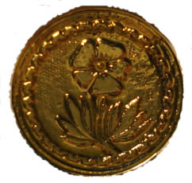
Flower
.68” dia
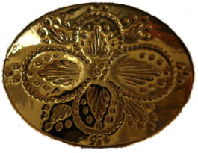
Quatrefoil
.61” x 80”
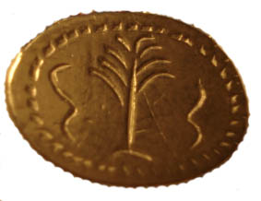
Palm Tree
.55” x .73”
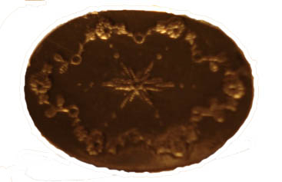
Starburst
.58” x .78”
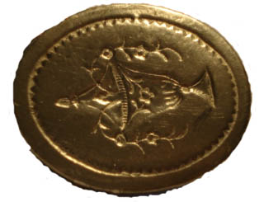
Urn
.66” x .82”
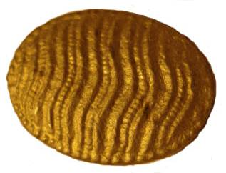  Wave  .41” x .55” | Solid Brass $15 | Solid Sterling Silver $25

