Shoe & Hi-Lo Inventory as of October 18, 2015
no more shoes are going to arrive

Crooked Last Shoes (Right/Left) $120/pr + shipping
14 D 5 pr | 15 D 1 pr

Pointed Toe Dress Shoes (Right/Left) $120/pr + shipping
10 D 1 pr
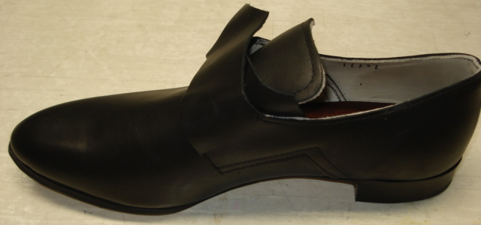
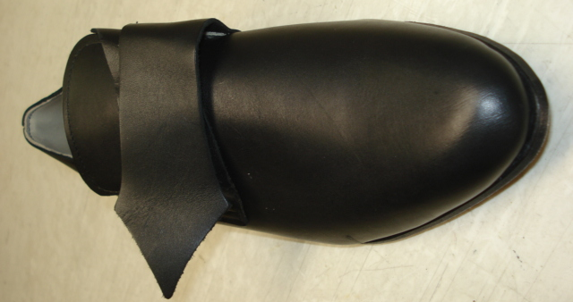
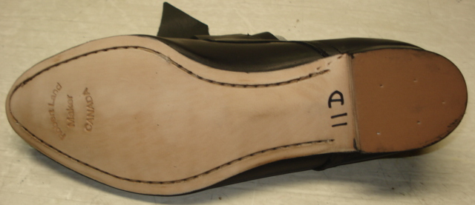
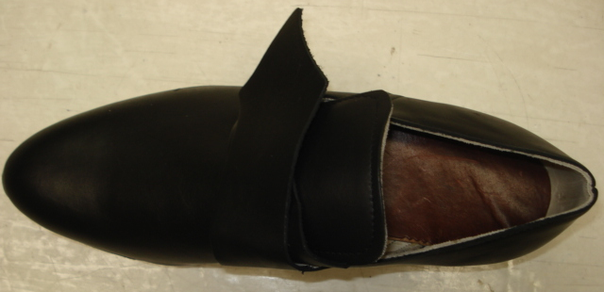
Hi-Lo’s (aka Half Boots) $140/pr + shipping
7 D 1 pr | 7 ½ D 1 pr | 12 EE 1 pr

