Sleeve (Cuff) Link Sets

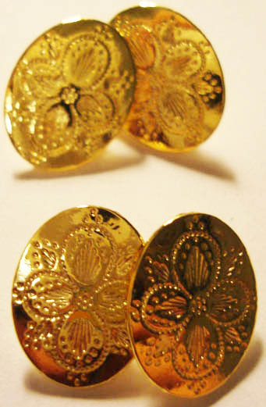
Enter the quantity of sets (or buttons) desired in the block, and return this form with your payment. Prices do not include shipping.

Each ‘set’ consists of sleeve/
cuff links for two shirt sleeves.
Prices are for one ‘set’ as
pictured here.

The individual buttons are also available.

Name: _________________________________

Address:________________________________

_______________________________________

_______________________________________

Phone: _________________________________

Email: _________________________________
Please print

 | Individual buttons  Pewter $.50 each  Silver or Gold plated $1.50 each | Pewter set  $7 | Sterling Silver Plated set $10 |  | 24kt Gold Plated set $10

Octogon
.45” dia
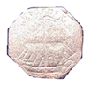
Victory Ship
.61” dia
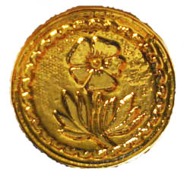
Flower
.68” dia
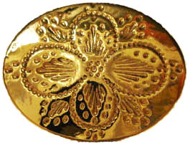
Quatrefoil
.61” x 80”
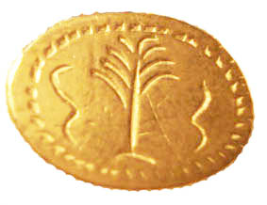
Palm Tree
.55” x .73”
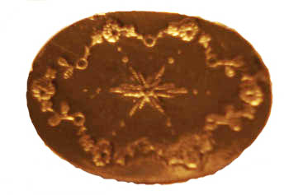
Starburst
.58” x .78”
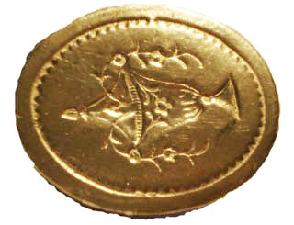
Urn
.66” x .82”
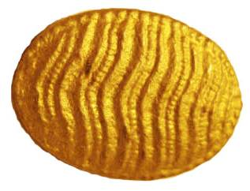  Wave  .41” x .55” | Solid Brass $15 | Solid Sterling Silver $25

